CHAPTER III
TECHNICAL BACKGROUND
This chapter describes the proposed technical approach for Land Grand. It explains the development tools, hardware, people involved, and offline operation. It also presents how Grade 5 learners at Baluan Elementary School will use the game.

Technicality of the project
This section explains how the proposed application will connect Science content with interactive activities. It describes the existing learning setting and the technical work needed to develop the game.
Land Grand will be an offline, single-player Android game about selected landforms, rocks, and minerals. Short lessons, exploration, item descriptions, and reviews will form its learning activities. The application will combine these activities in a two-dimensional (2D) environment with touch controls.

Current learning and technical setting
This section describes the learning arrangements relevant to the project. It distinguishes the existing materials from the proposed digital resource.
According to the researcher's October 2026 account, Baluan Elementary School holds face-to-face classes. Printed materials and adult guidance remain part of the project's home-study context. Modular learning is described as an option if a disaster interrupts classroom instruction.
The existing parent and teacher survey includes reports of access to phones, tablets, or computers. These reports do not confirm access to Android devices that meet the game's requirements. Land Grand will therefore serve as an additional learning resource alongside printed materials and teacher guidance.
The proposed application will place its learning content and saved progress on the device. Its operation will not depend on a school server or a continuous internet connection.

Development
This section explains how the proposed software components and learning materials will be combined. It describes the main technical tasks involved in preparing the application.
The developer will prepare lesson text, item descriptions, illustrations, and graphical assets for the selected topics. These materials will be arranged into game scenes and connected through the application's scripts. The lessons and selected examples will require scientific and curriculum review before use.
The game scenes will connect the lesson, exploration, collection, and review activities. Touch controls will support movement and jumping. Item collection will display the relevant illustration, name, and short description. The progress system will record available content and completed activities on the device.
The developer will prepare an Android build and check a complete level on the intended devices. These checks will examine the lesson display, controls, item information, results, and continuation from saved progress. Their outcomes will guide later development.

Details of the technologies to be used
This section explains the proposed hardware, software, and peopleware for Land Grand. It also describes the network boundary of the offline application.

Hardware
This section presents the declared development equipment and proposed learner-device targets. The development computer will support application preparation, while Android phones and tablets will run the game.
The declared development computer has the following specifications:
• Processor: 11th Gen Intel Core i7-1185G7 at 3.00 GHz
• Memory: 16 GB random-access memory (RAM), 2400 MHz
• Graphics: Intel Iris Xe Graphics
• Storage: 256 GB solid-state drive (SSD)
The proposed minimum targets for the learner's device are:
• Device: Android phone or tablet
• Operating system: Android 10 and above
• Memory: 2 GB RAM
• Available storage: 300 MB free space
The learner-device targets remain subject to testing. Actual memory use, installation size, and performance will depend on the completed build and the device used. The stated targets do not establish compatibility with every Android device.

Software
This section describes the planned software tools and their roles in the project. It explains how the operating system, game engine, graphics tools, code editor, and build tools will support development.

Development Operating System
This section identifies the operating system in the declared development setup. It explains its role in running the project tools.
The proposed development environment will use Windows 11, 64-bit. The developer will use this environment to manage project files, prepare assets, edit scripts, and produce application builds. Windows is the development platform; Android is the intended platform for learners.

Game Engine
This section describes the planned role of Unity in Land Grand. It explains how the engine will bring the game's components together.
Unity will be used to arrange the two-dimensional scenes, interface elements, audio, and graphical assets. It will connect touch input with character actions and the collection activities. The project will also use Unity to prepare its Android build.

Editing Software
This section describes the tools selected for the game's visual materials. It explains their planned contributions to the graphics workflow.
Piskel will be used to prepare pixel-art sprites and frame-based animations for the game. The planned outputs include character and item images for use in Unity. This work will support the game's two-dimensional presentation.
Clip Studio Paint supports illustration and animation work (Celsys, 2025). In Land Grand, the developer plans to use it for selected illustrations and graphical assets. These materials will provide visual examples alongside the lesson text and item descriptions. The planned digital illustrations will supplement physical examples and teacher explanations.

Code Editor
This section explains the role of Visual Studio Code in preparing the application scripts. It describes the editing support relevant to Unity development.
Visual Studio Code will be the selected code editor for C# scripts. Microsoft's Unity guide describes code completion and debugging through the appropriate Unity and C# extensions (Microsoft, 2023). The developer will configure the editor and extensions for the project. These tools will support script preparation and debugging during development.

Programming Language
This section describes how C# will be used in the application. It identifies the planned game functions controlled by scripts.
C# scripts will connect the interface, character actions, item collection, and scene changes. They will also control access to available levels, prepare level results, and handle local progress data. These functions will follow the documented scope and the game rules established during design.

Android Build Tools and Installation Package
This section explains the tools needed to prepare an Android application package. It distinguishes application installation from the game's planned offline operation.
Unity's Android documentation identifies Android Build Support and the Android Software Development Kit (SDK) as build dependencies. It also lists the Native Development Kit (NDK) and a Java Development Kit (JDK). Unity uses OpenJDK by default (Unity Technologies, 2026). The development setup will use dependency versions compatible with the selected Unity editor.
An Android Package (APK) contains the components needed to install and run an application on Android devices (Google, 2025). The proposed Land Grand build will be prepared as an installable APK. After installation, its planned lessons, graphical assets, audio, and progress functions will be available on the device. Offline operation will depend on including these resources locally and avoiding online service dependencies.

Peopleware
This section describes the people involved in developing and using Land Grand. It distinguishes development responsibilities from the support provided during learning.
The researcher, acting as the developer, will prepare the application and organize its learning materials. The researcher will also carry out the planned technical checks. Science content will require review for accuracy and suitability for Grade 5 learners. Content review is planned work rather than completed validation.
Grade 5 learners at Baluan Elementary School will be the intended players. They will use the application as an additional resource for the selected Science topics. The proposed interface will use large touch buttons for the main character actions.
Teachers may guide learners and provide feedback on the proposed Science materials. Parents or guardians may assist with home study and device use. These supporting roles do not require online accounts or access to centralized learner records. Participation in a formal evaluation will depend on the study's documented arrangements.

Network and Offline Operation
This section explains the application's planned network requirements and local data handling. It describes the boundaries of offline use.
Land Grand will be designed for gameplay without an internet connection after installation. Lessons, item illustrations, audio, and progress data will be kept on the device. The project will not include multiplayer, online accounts, cloud storage, a website, or an administrator panel.
Saved progress will remain on the device used for play. The proposed application will not provide central teacher monitoring or shared learner records. Obtaining and installing the application package is separate from playing the installed game.

How the project will work
This section explains how learners will use Land Grand and how the game will save their progress. Figures 4A to 4E show the proposed procedure.
Land Grand will load available progress from the device at startup. The Main Menu will offer Play, Settings, Tutorial, and Exit. Play will open the Landform Map (Figure 4A).
Learners will select an unlocked episode and an available level. The four episodes will cover Mountains, Hills, Plains, and Plateaus. Each episode will have three Easy, five Normal, and seven Hard levels, for a total of 60 (Figure 4B).
Before each level, a short lesson will introduce the landform and related rocks or minerals. Learners will move and jump with touch controls. An item pop-up will show each collected item's illustration, name, and short description. Reaching the end goal will complete the level. If time runs out or the learner falls into a pit, the game will offer Retry and Back to Main Menu (Figure 4C).
The game will award up to three stars using thresholds for the number of rocks collected. It will automatically save the level result on the device. Clearing all three Easy levels will unlock Normal. Clearing all five Normal levels will unlock Hard. The Result Screen will show earned stars, collected items, and a short review (Figure 4D).
Learners may replay or continue to the next available level. After the required levels are complete, the game will show a landform summary and unlock the next episode if available. The Completion Screen will show total stars, collected items, and a congratulatory message after all four episodes (Figure 4E).
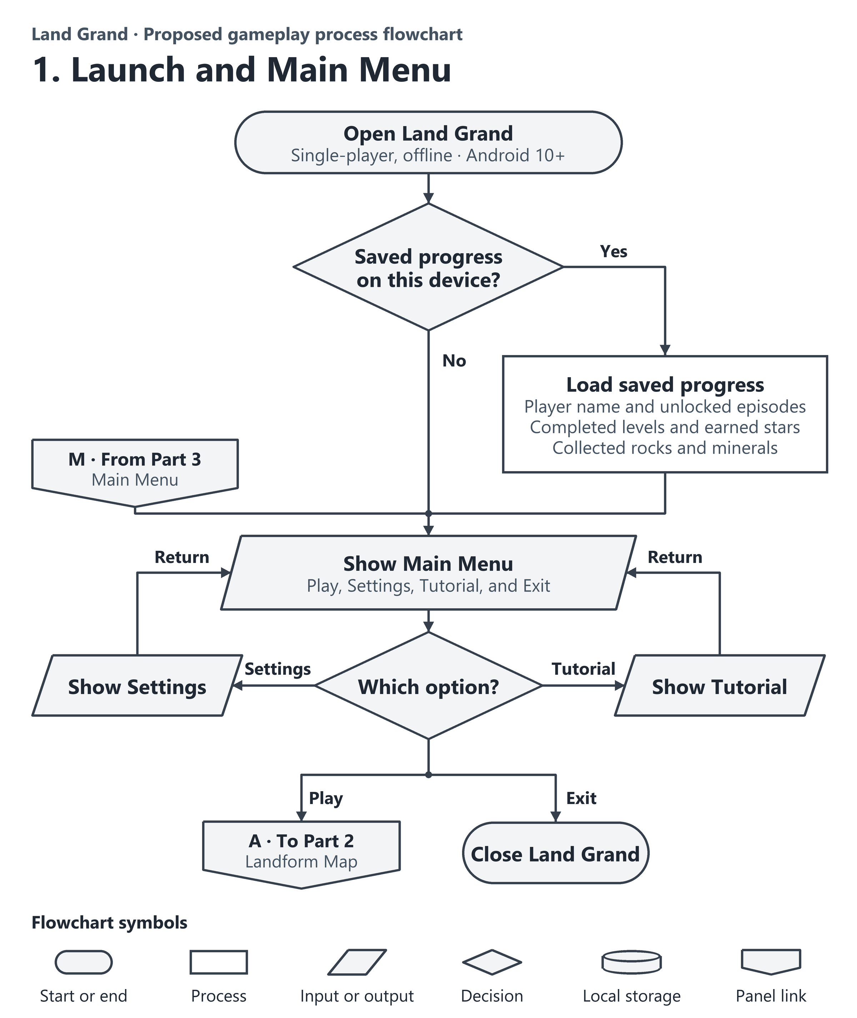
Figure 4A. Launch and Main Menu
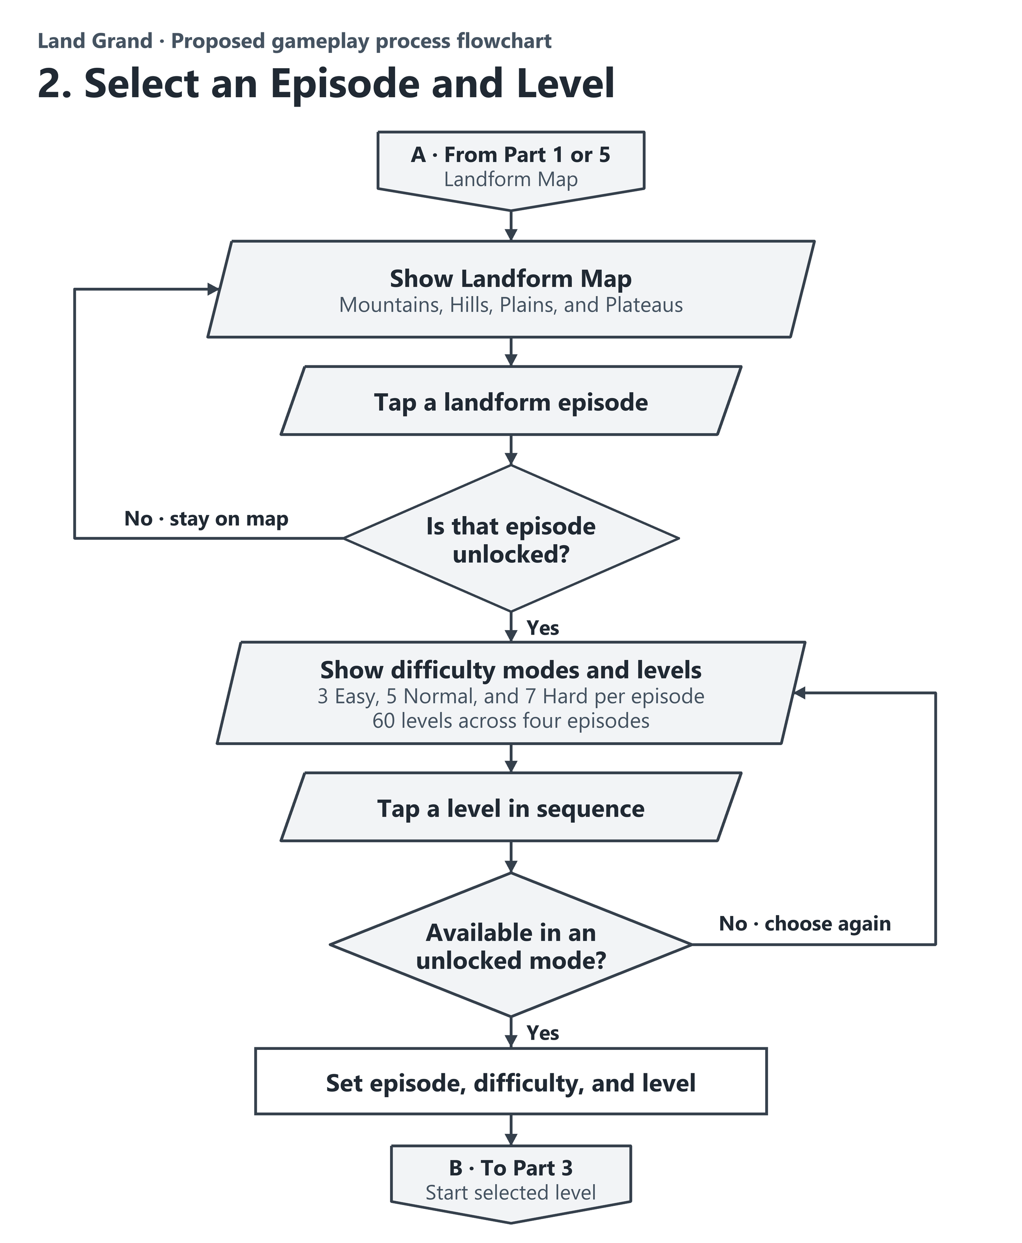
Figure 4B. Episode and Level Selection
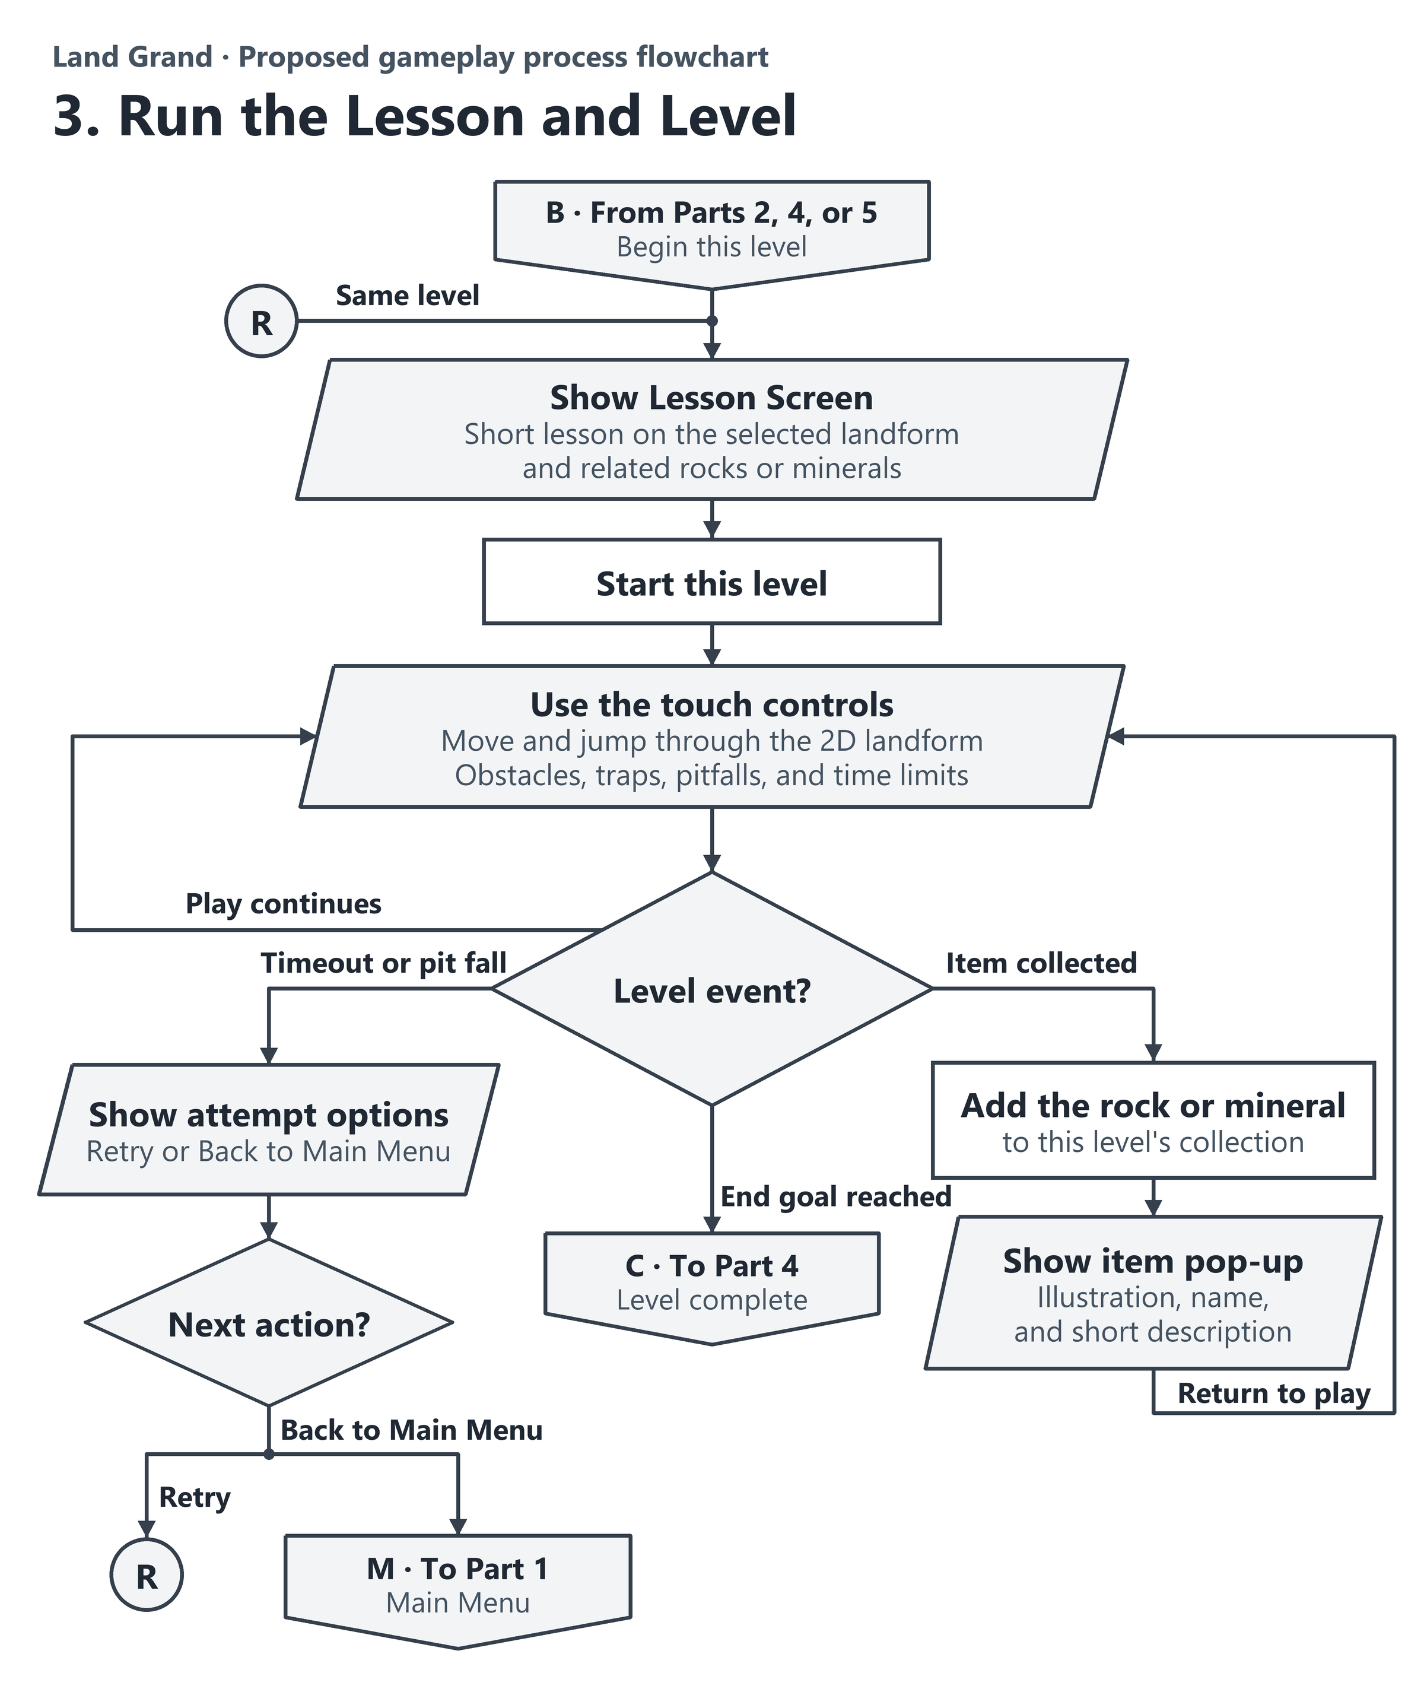
Figure 4C. Lesson and Level Outcomes
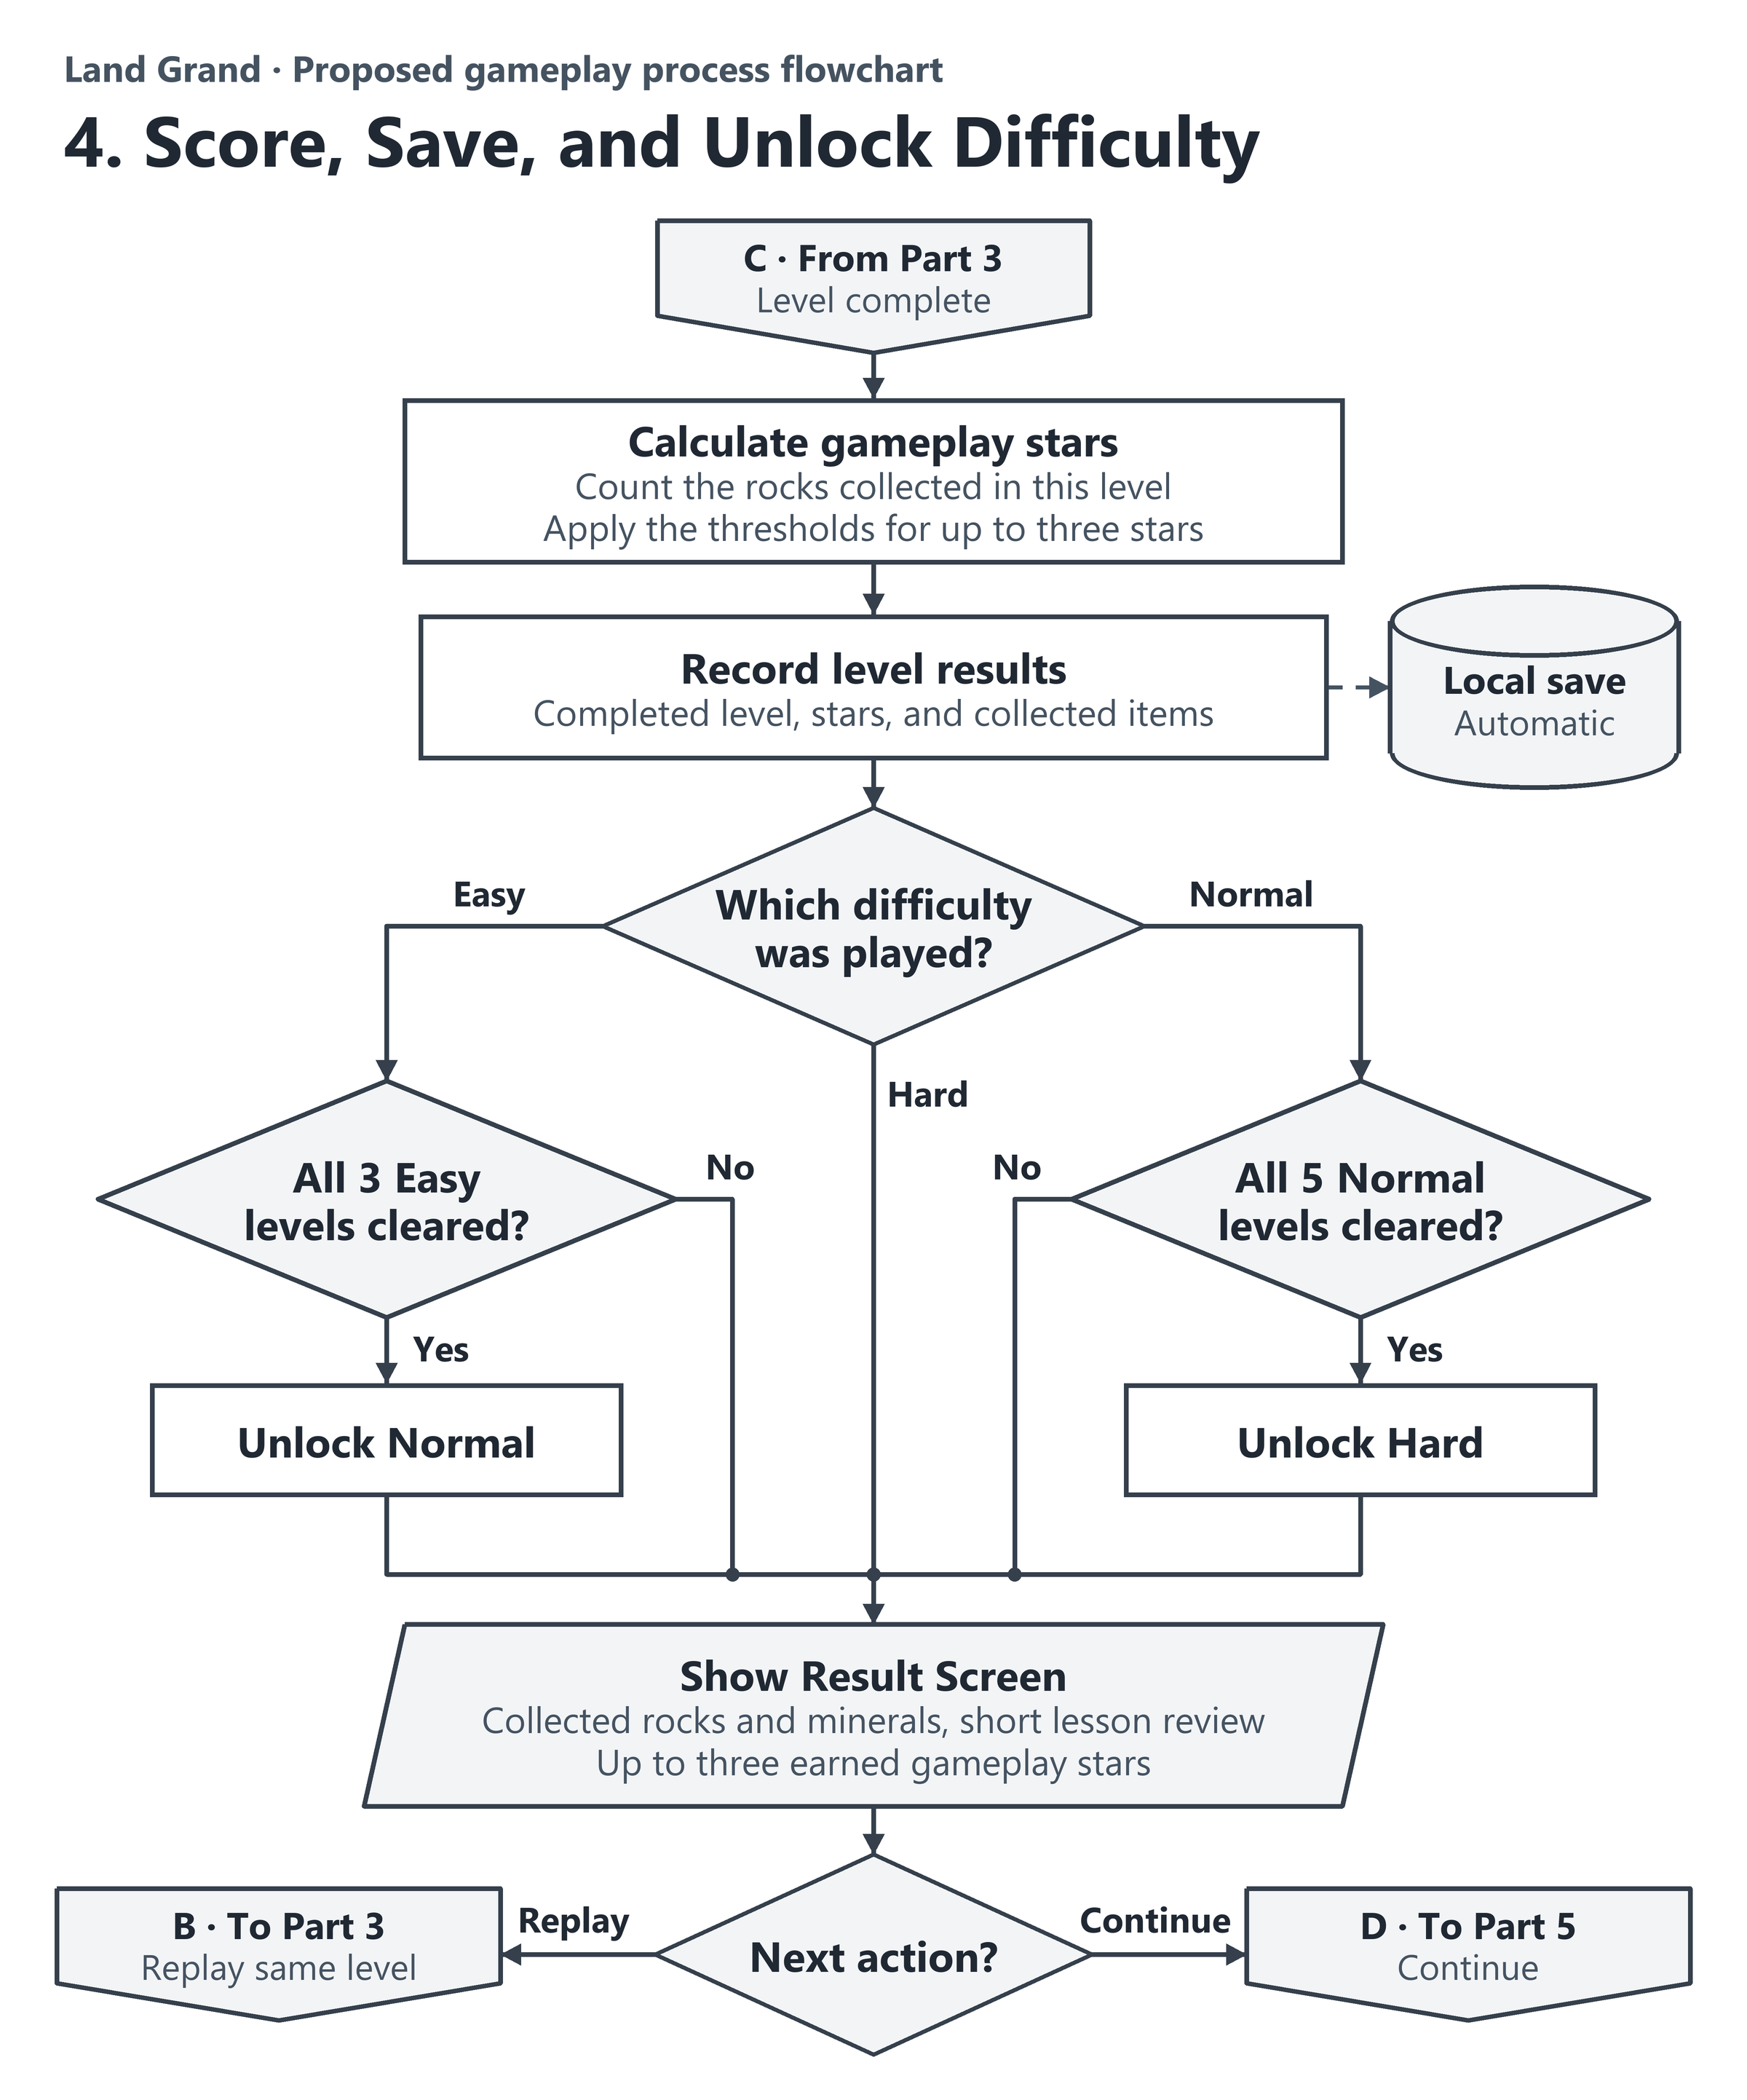
Figure 4D. Scoring, Local Saving, and Difficulty Unlocks
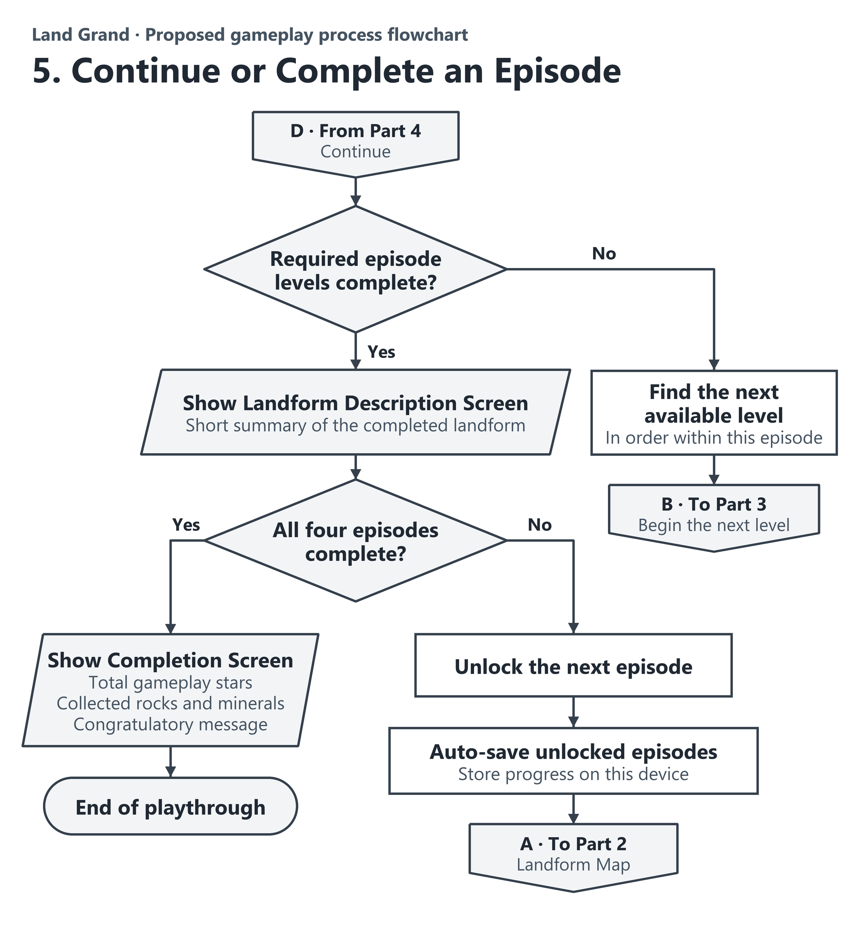
Figure 4E. Episode Progression and Game Completion

